Chicken Pot Pie
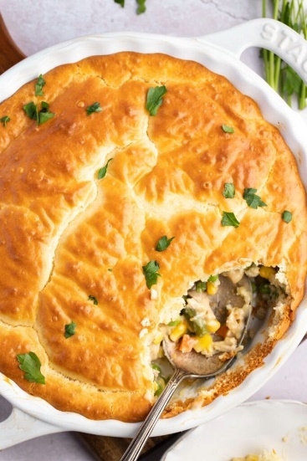

Ingredients:
- 1 or 2 cans Condensed Cream of Chicken Soup
Serves as the creamy gravy the chicken and vegetables are covered in. (1 or 2 cans depending on how much Pie you’re planning to making!)
- Pillsbury Grands! – Southern Style Biscuits.
Place biscuits in casserole dish (touching) so you will know how many you will need. Take them out and let thaw on a none-stick surface. (I use Aluminium foil sprayed with Pam.)
- 1 bag Mixed Vegetables – Just get a bag of frozen vegetables instead of chopping up fresh ones. (It’s a total time-saver!)
- 1 Chicken or Turkey – No need to cook from scratch. Rotisserie chicken or leftovers will do. (You can either shred the meat or slice it into cubes.)
Instructions:

All you’ll need to do is combine the ingredients, pour them into a casserole dish, place biscuits (touching each other) all over the top and pop it in the oven. Cook according to the instructions on the Becket package.

